We have a Linux server and we need to access the s3 bucket from the server . what are the steps we have to follow?

First, we need to perquisite requirements to understand the procedure to accessing the s3 bucket from sever .

We need

Launch the EC2 Server Linux, Window ,Ubuntu ,etc.

Now go to S3 service

Need to create s3 bucket and upload the data there and configure the s3 . / buckets such as:

Buckets are containers for data stored in s3.

General configuration:

* + - Aws region
    - Bucket type ,
    - Bucket name ,---- Bucket name must be unique within the global namespace and follow the bucket naming rules
    - Object ownership, -----control ownership of objects written to this bucket from other AWS accounts and the use of access control lists (ACLs). Object ownership determines who can specify access to objects.
    - Block public access settings
    - Edit permission policy ,
    - Versioning enable, ------ Versioning is a means of keeping multiple variants of an object in the same bucket. You can use versioning to preserve, retrieve, and restore every version of every object stored in your Amazon S3 bucket.
    - Tags, Default encryption ,bucket key -enable or disable
    - Server Access enabling,
    - Now click :--- create bucket

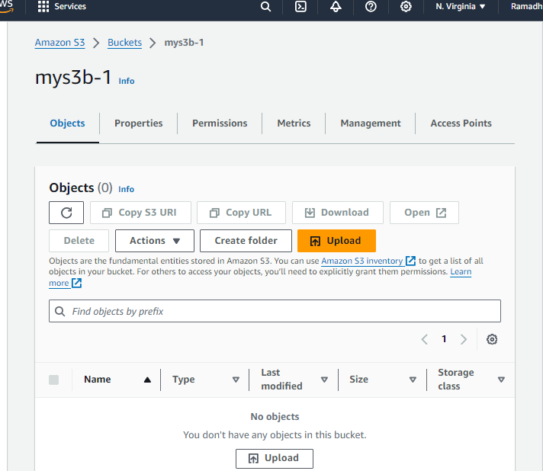

Now go to instance connect it after loggin into it

Now try to list the s3 bucket :

Aws s3 ls

It will ask for the credential to access the s3 buckets from one Aws account but we need to access the s3 buckets from the instance server so we are not going to put credentials.

So we need to add role and attach the roles to ec2 instances to access tye s3 bucket from the server as a user.

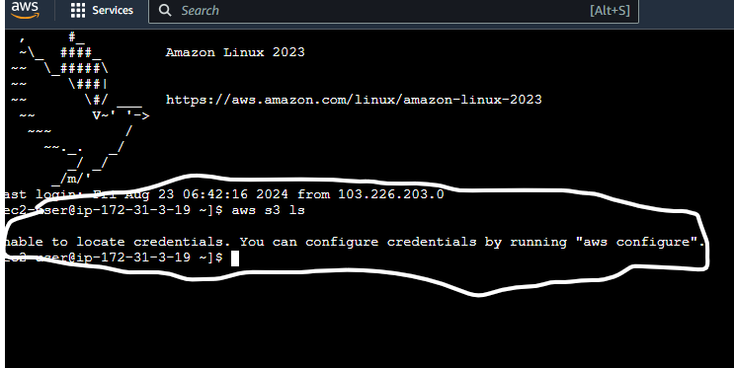

IAM policies:

Now go to service IAM roles and policies :

* Create &add roles
* Create roles for that service you want
* Edit permission policies
* Attach policies to IAM Entities

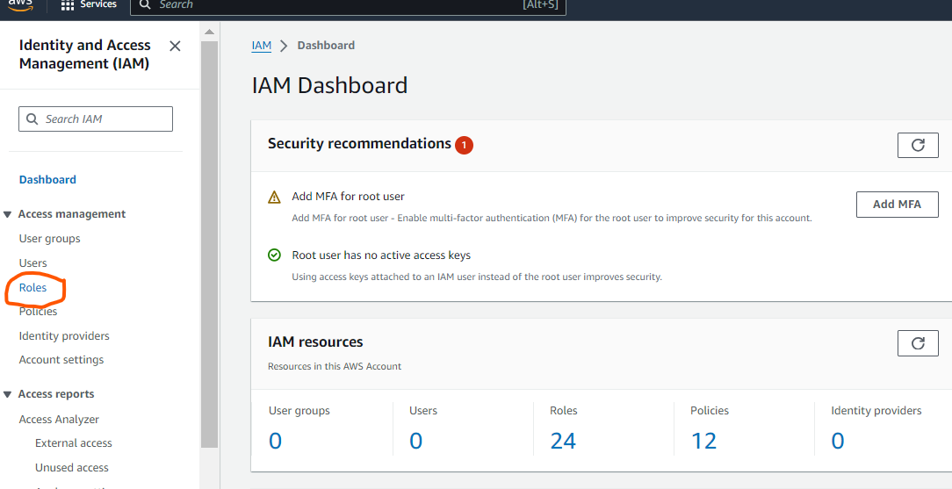

Click : create role

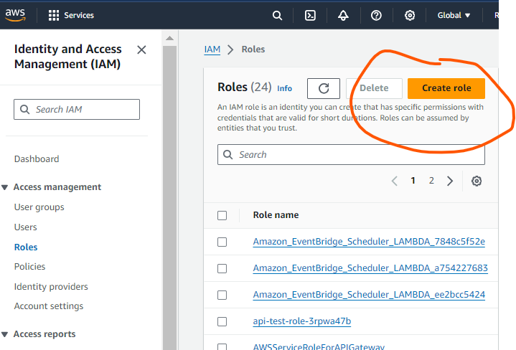

* Select trusted entity
* And use cases
* Click : --- Next

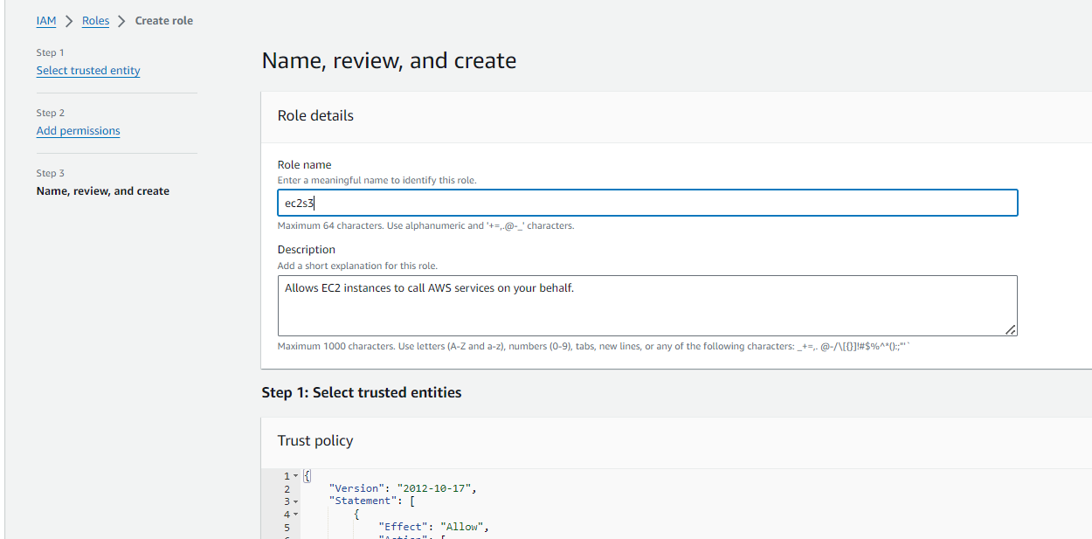

It will show on roles dashboard.

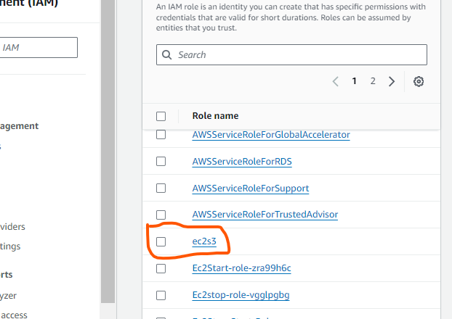

Now click that role just created before and add permissions

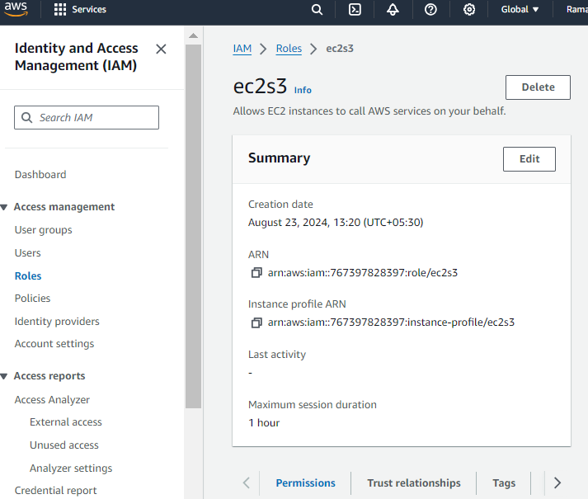

Now click : Permissions and add inclined permission policy

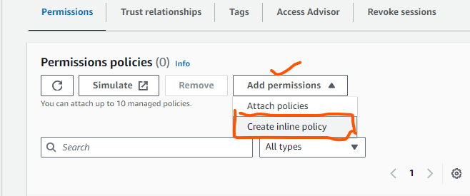

Now choose service which service we r trying to access is s3 bucket so choose s3 service

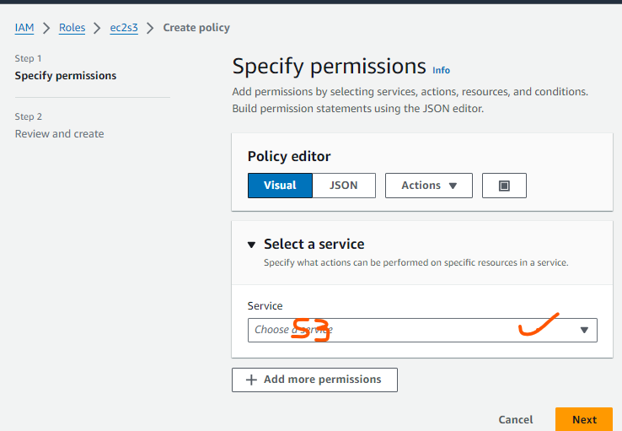

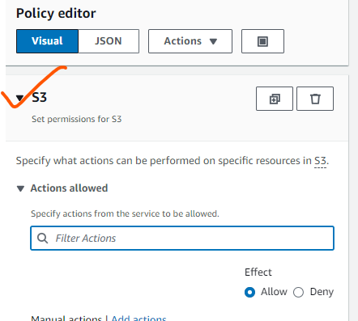

Specify what actions can be performed on specific resources in S3

.

#### Actions allowed

Specify actions from the service to be allowed.

Effect

Allow

Deny

Manual actions

Add actions

All S3 actions (s3)

List (15) ------ click :- all my objects

Read (60) -----------click:- get object

Write (57) ------------click:- put object

Permissions management (15)

Tagging (12)

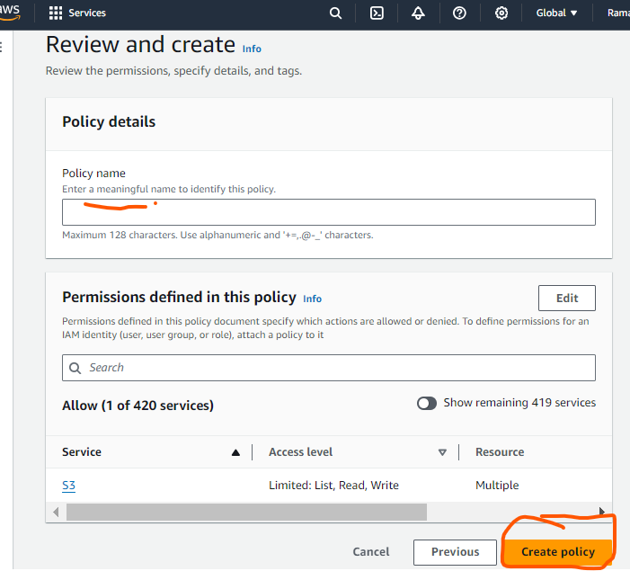

Click :- create policy

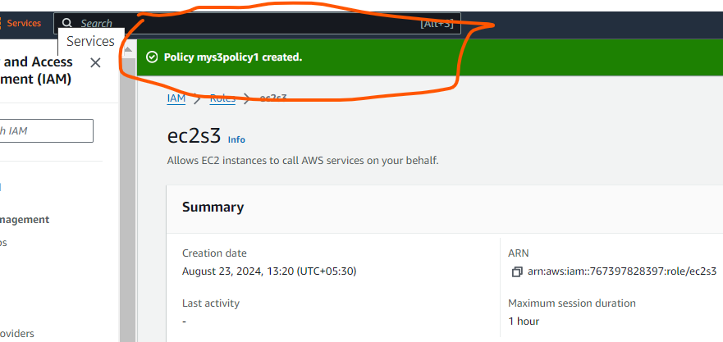

Now go to instance details

Select ----Actions--- go to ----security ----modify IAM roles

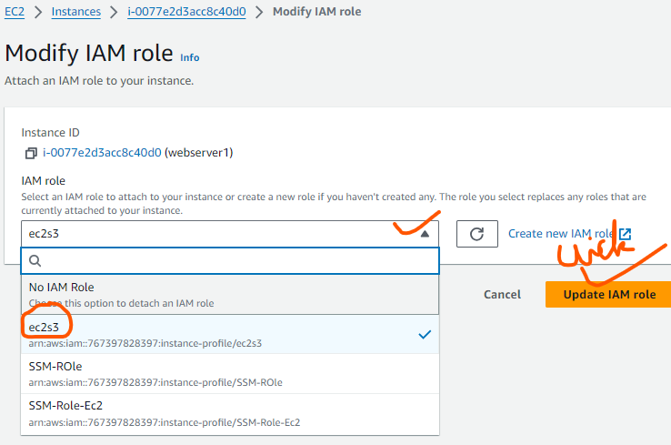

Now successfully update with iam policy

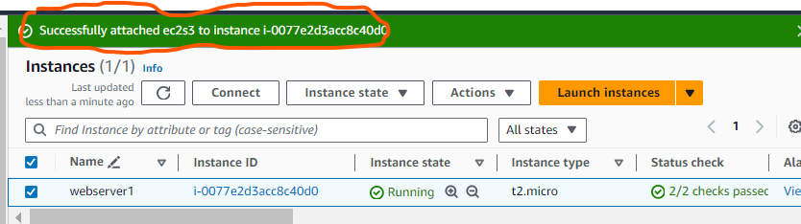

Now connect to server through putty and logging into it

To see available all the buckets , run

] $ aws s3 ls

Now it will show your s3 bucket on server

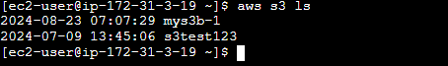

It is now showing all the buckets .

To listing the object within the s3 bucket

Run ]$ aws s3 ls s3://mys3b-1

But if we wanted to access the second one s3 bucket we get access denied because we have only allowed for accessing the mys3b-1 bucket .

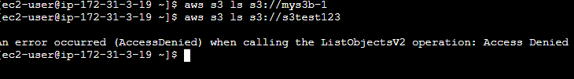

See the results

Summary commands :----

To access the s3 bucket run

] $ aws s3 ls sourcename

For eg. $ aws s3 ls://mys3b-1

To create a file in s3 bucket , run

] $ echo “hello world” >source-name demo.text

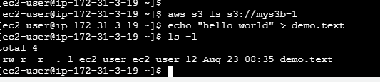

Check whether is created or not so run ] $ ls -l

If we want to copy the file to existing or any s3 bucket, run

] $ aws s3 cp source destination

For eg. ] $ aws s3 cp demo.text s3://mys3b-1



It will show the uploaded file on s3 aws console . you can check there .

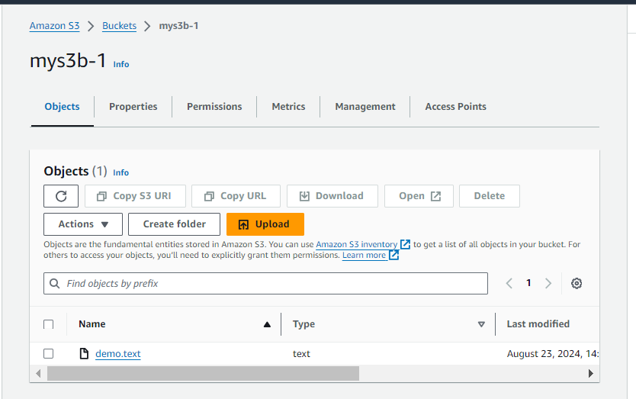

Now if we want to remove the file from s3 bucket ,run

] $ rm -rf demo.text

To Check run ]$ ls -l

If we want to downloaded the file ,run

] $ aws s3 cp s3://s3bucket123/demo.text .



Now if we want to delete the file from s3 bucket ,run

] $ aws s3 rm s3://s3bucket123/demo.text

To Check run ]$ ls -l